This is a solid vision—and very aligned with how professional security assessments are actually done in the field 👍
I’ll give you a structured, execution-ready architecture that fits your constraints (MSMEs, minimal infra, Windows laptop, mostly CLI, mix of domain/non-domain).

🧩 DXSO MSME Security Assessment – Technical Architecture
We’ll break this into phases, each with:
- Objective
- Tools
- Script approach
- Execution method
- Output

🚀 PHASE 1: Network Asset Discovery

🟢 Step 1: Identify All Devices in Network
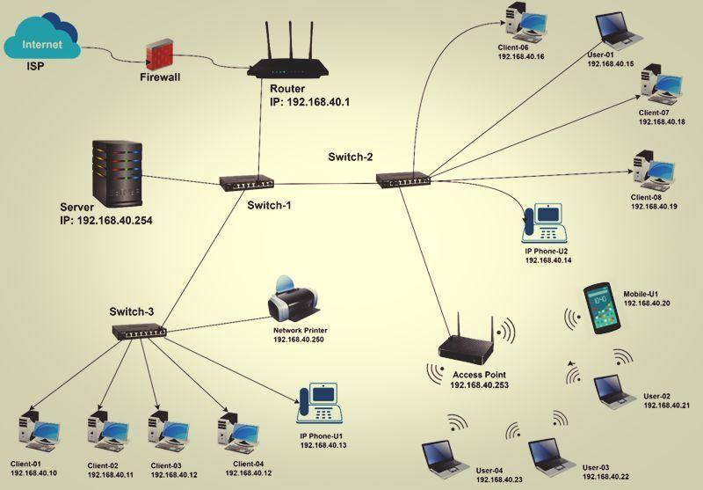
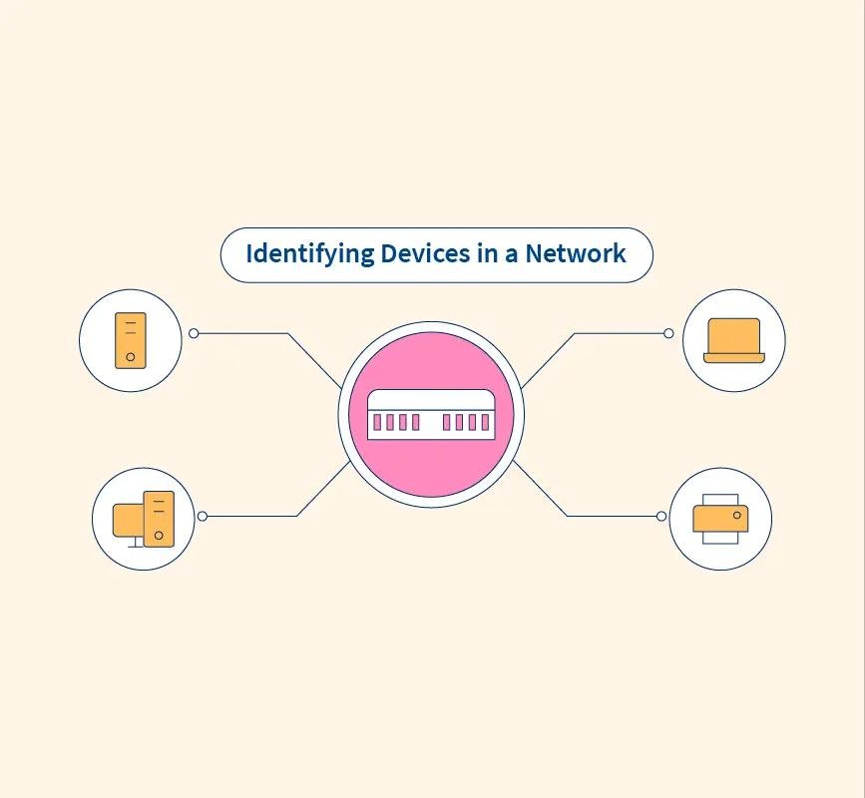
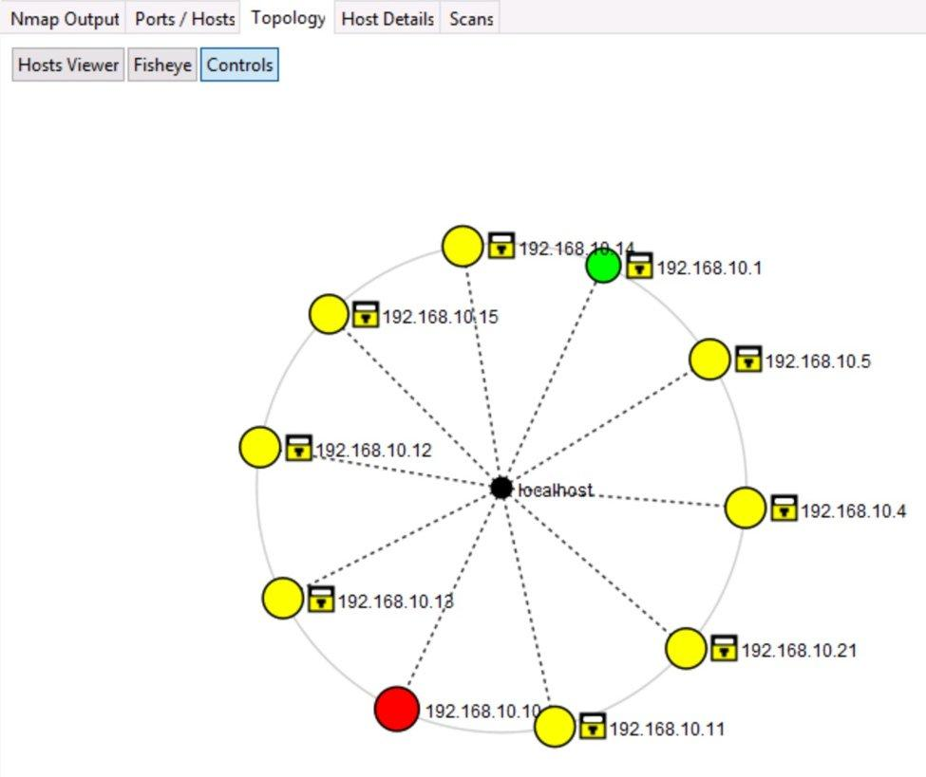
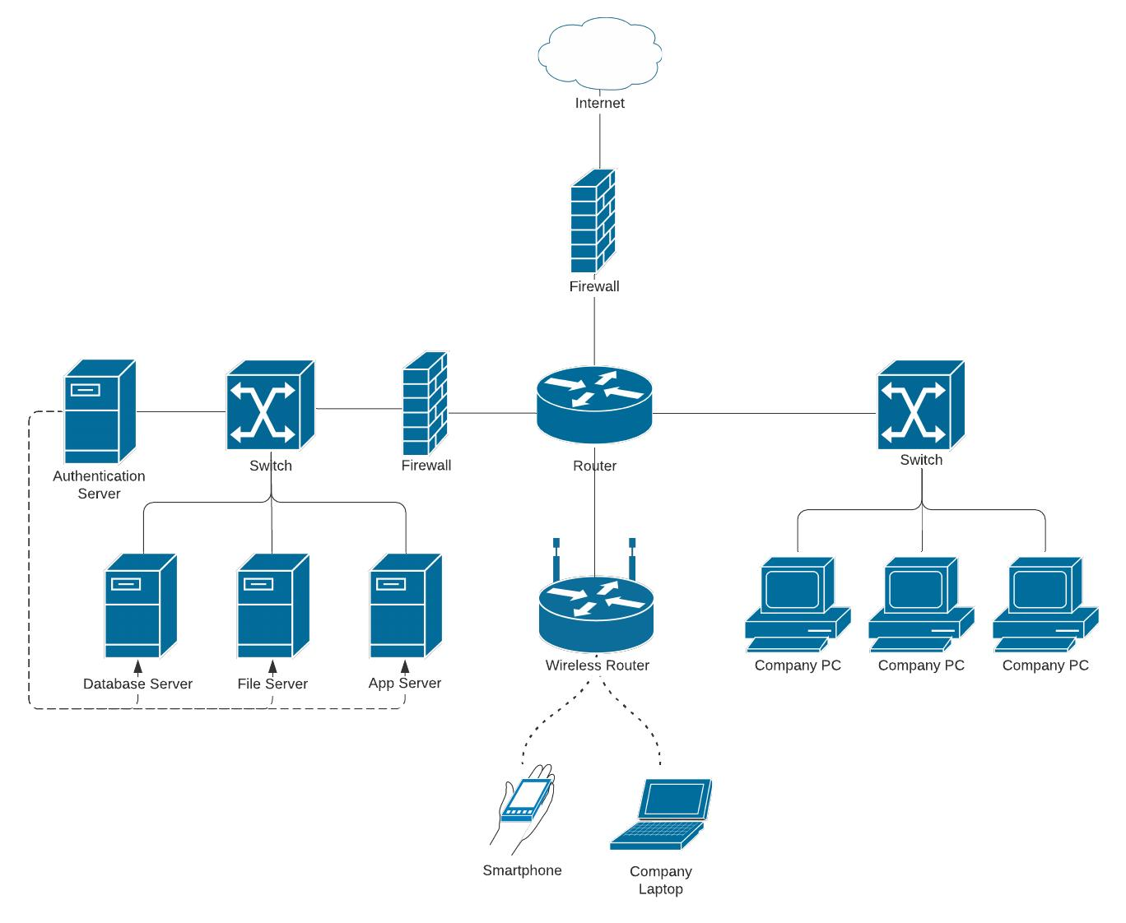
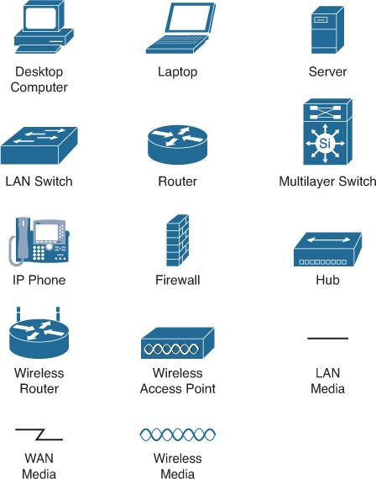
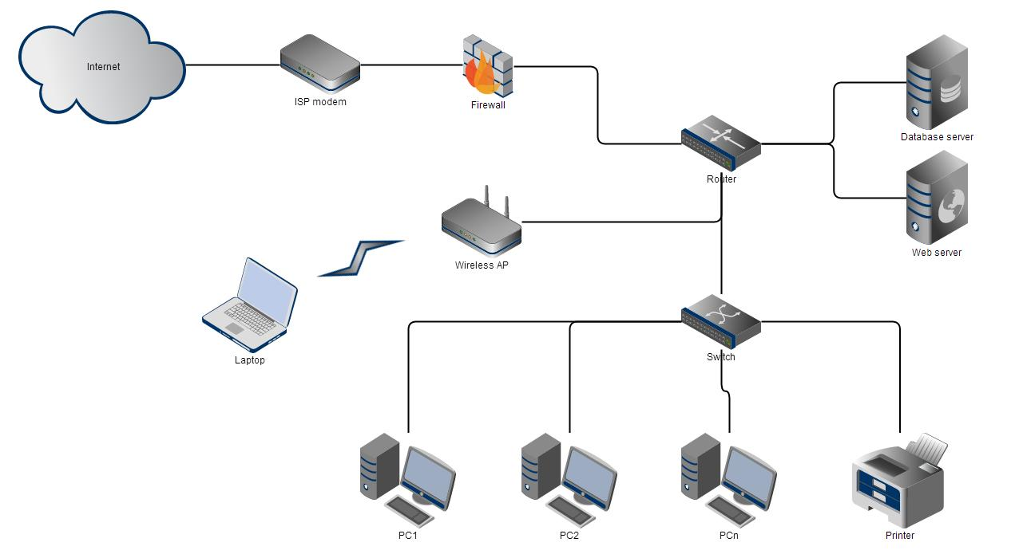

🔹 Name
Network Asset Discovery

🔹 Objective
Identify:
- Laptops / desktops
- Mobiles
- Routers / switches
- CCTV / IoT

🔹 Tools
- Nmap
- arp-scan
- netdiscover

🔹 Script Language
👉 Bash (via WSL) OR Python

🔹 Command (Core)
nmap -sn 192.168.1.0/24 -oN live_hosts.txt

🔹 Advanced Detection
nmap -A -T4 -O 192.168.1.0/24 -oN detailed_scan.txt

🔹 Pre-requisites
- Connect laptop to LAN
- Identify subnet (192.168.x.x)
- Admin/root privileges

🔹 Output
- live_hosts.txt → All IPs
- detailed_scan.txt → OS + services

🔹 Outcome
✅ Full inventory of connected devices

🚀 PHASE 2: Endpoint Deep Discovery (Critical)

🟢 Step 2: Local System Data Extraction
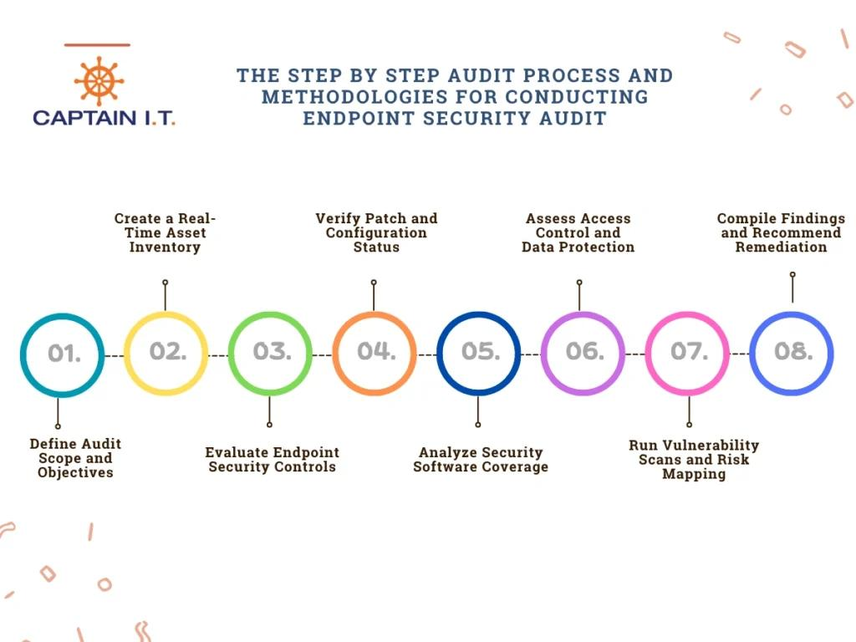
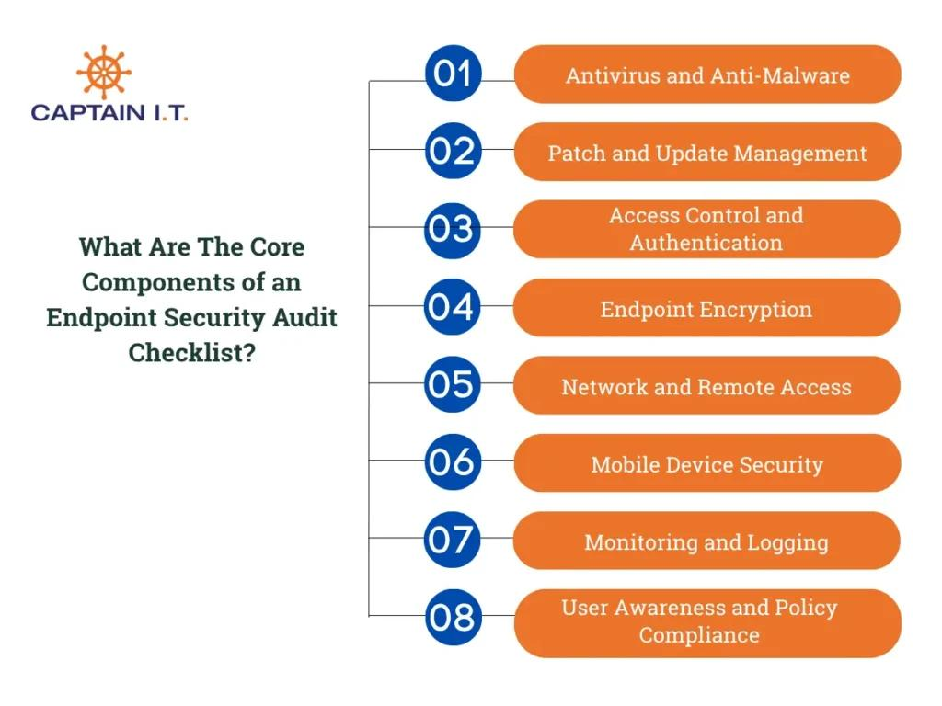
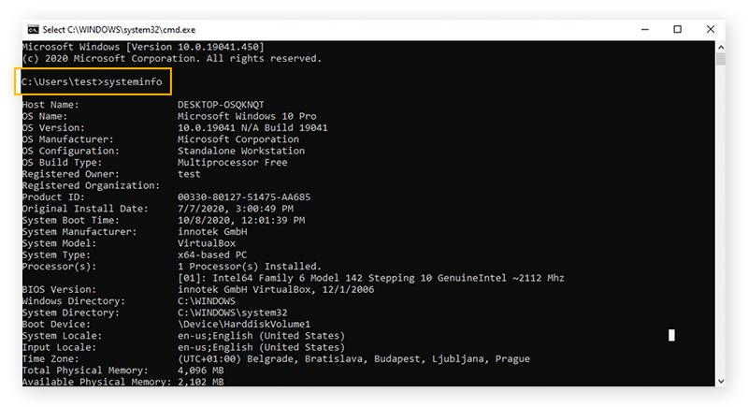
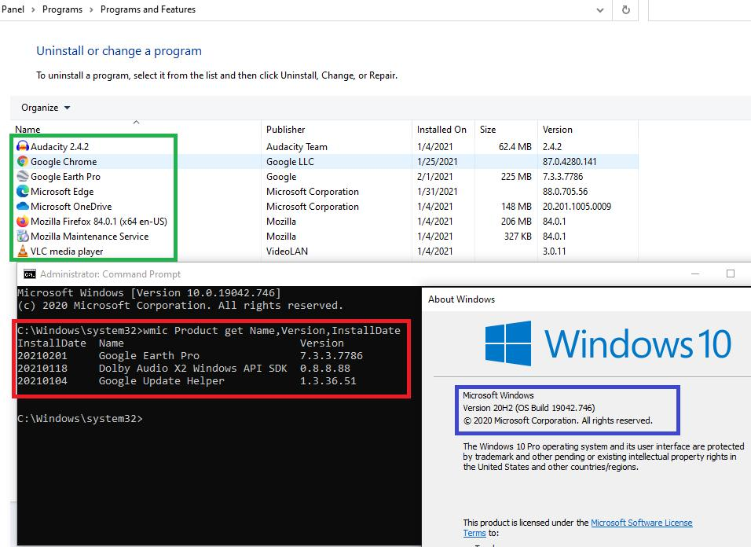
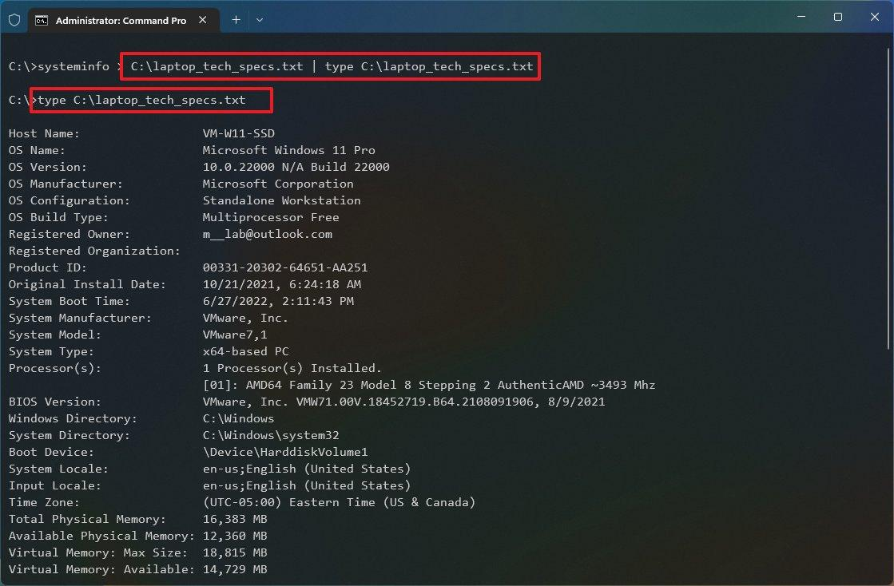
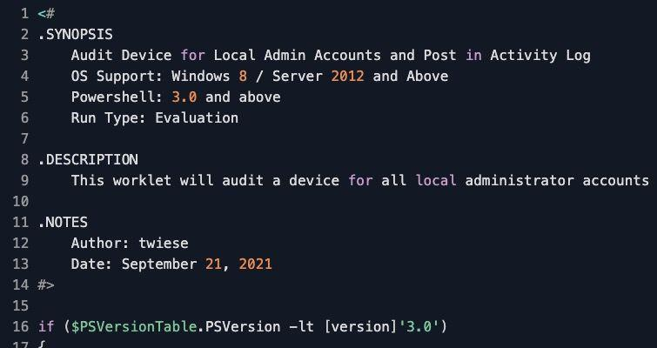

🔹 Name
Endpoint Configuration & Software Audit

🔹 Objective
Extract:
- OS version
- License status
- Installed software
- Login type (Domain vs Local)
- Running processes
- Security posture

🔹 Tools
- PowerShell
- PsExec

🔹 Script Language
👉 PowerShell (MANDATORY — no WMIC)

🔹 Execution Strategy
You have 2 options:

Option A (Manual – MVP)
- Copy script to each system
- Run locally
- Save output

Option B (Better)
psexec \\IP -u admin -p pass powershell -File audit.ps1

🔹 Sample Script Logic
$Output = "C:\audit\$env:COMPUTERNAME.txt"

# OS Info
Get-CimInstance Win32_OperatingSystem | Out-File $Output

# Software
Get-ItemProperty HKLM:\Software\Microsoft\Windows\CurrentVersion\Uninstall\* |
Select DisplayName, DisplayVersion | Out-File $Output -Append

# Login Info
"$env:USERNAME - $env:USERDOMAIN" | Out-File $Output -Append

# Domain Info
Get-CimInstance Win32_ComputerSystem | Select Domain | Out-File $Output -Append

# Running Apps
Get-Process | Out-File $Output -Append

🔹 Pre-requisites
- Admin credentials
- SMB enabled
- Firewall open

🔹 Output
- One file per system
- Stored locally or shared folder

🔹 Outcome
✅ Deep endpoint visibility

🚀 PHASE 3: Wireless Security Assessment

🟢 Step 3: Wi-Fi Security Analysis
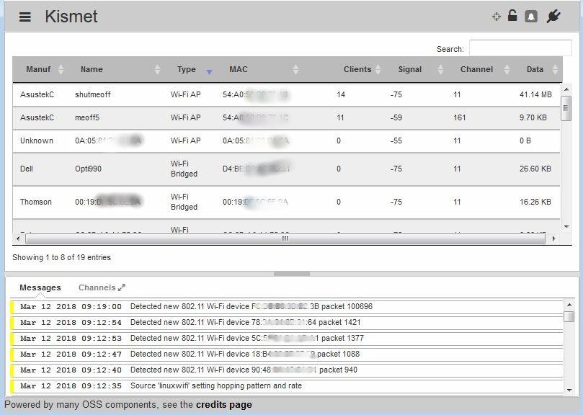
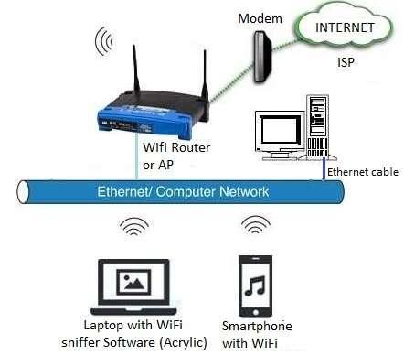
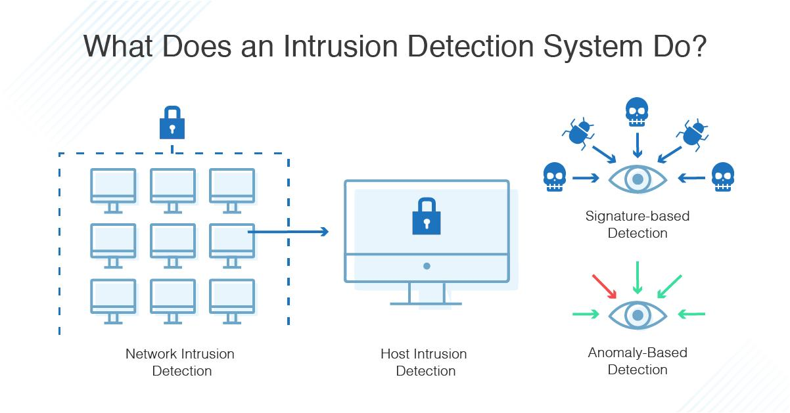
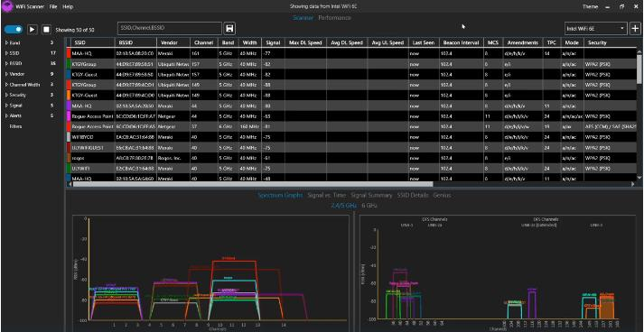
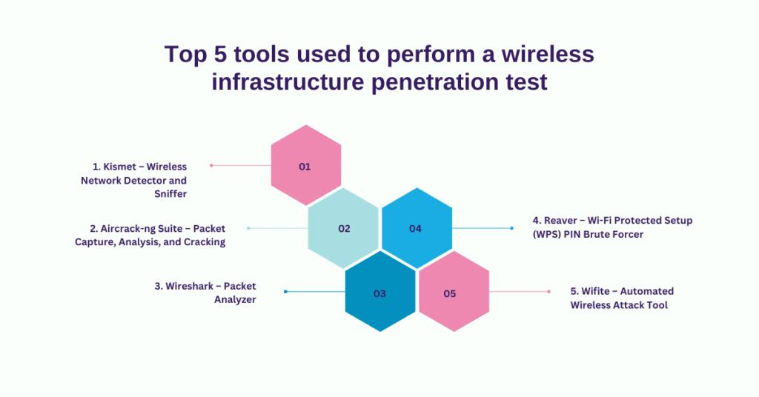
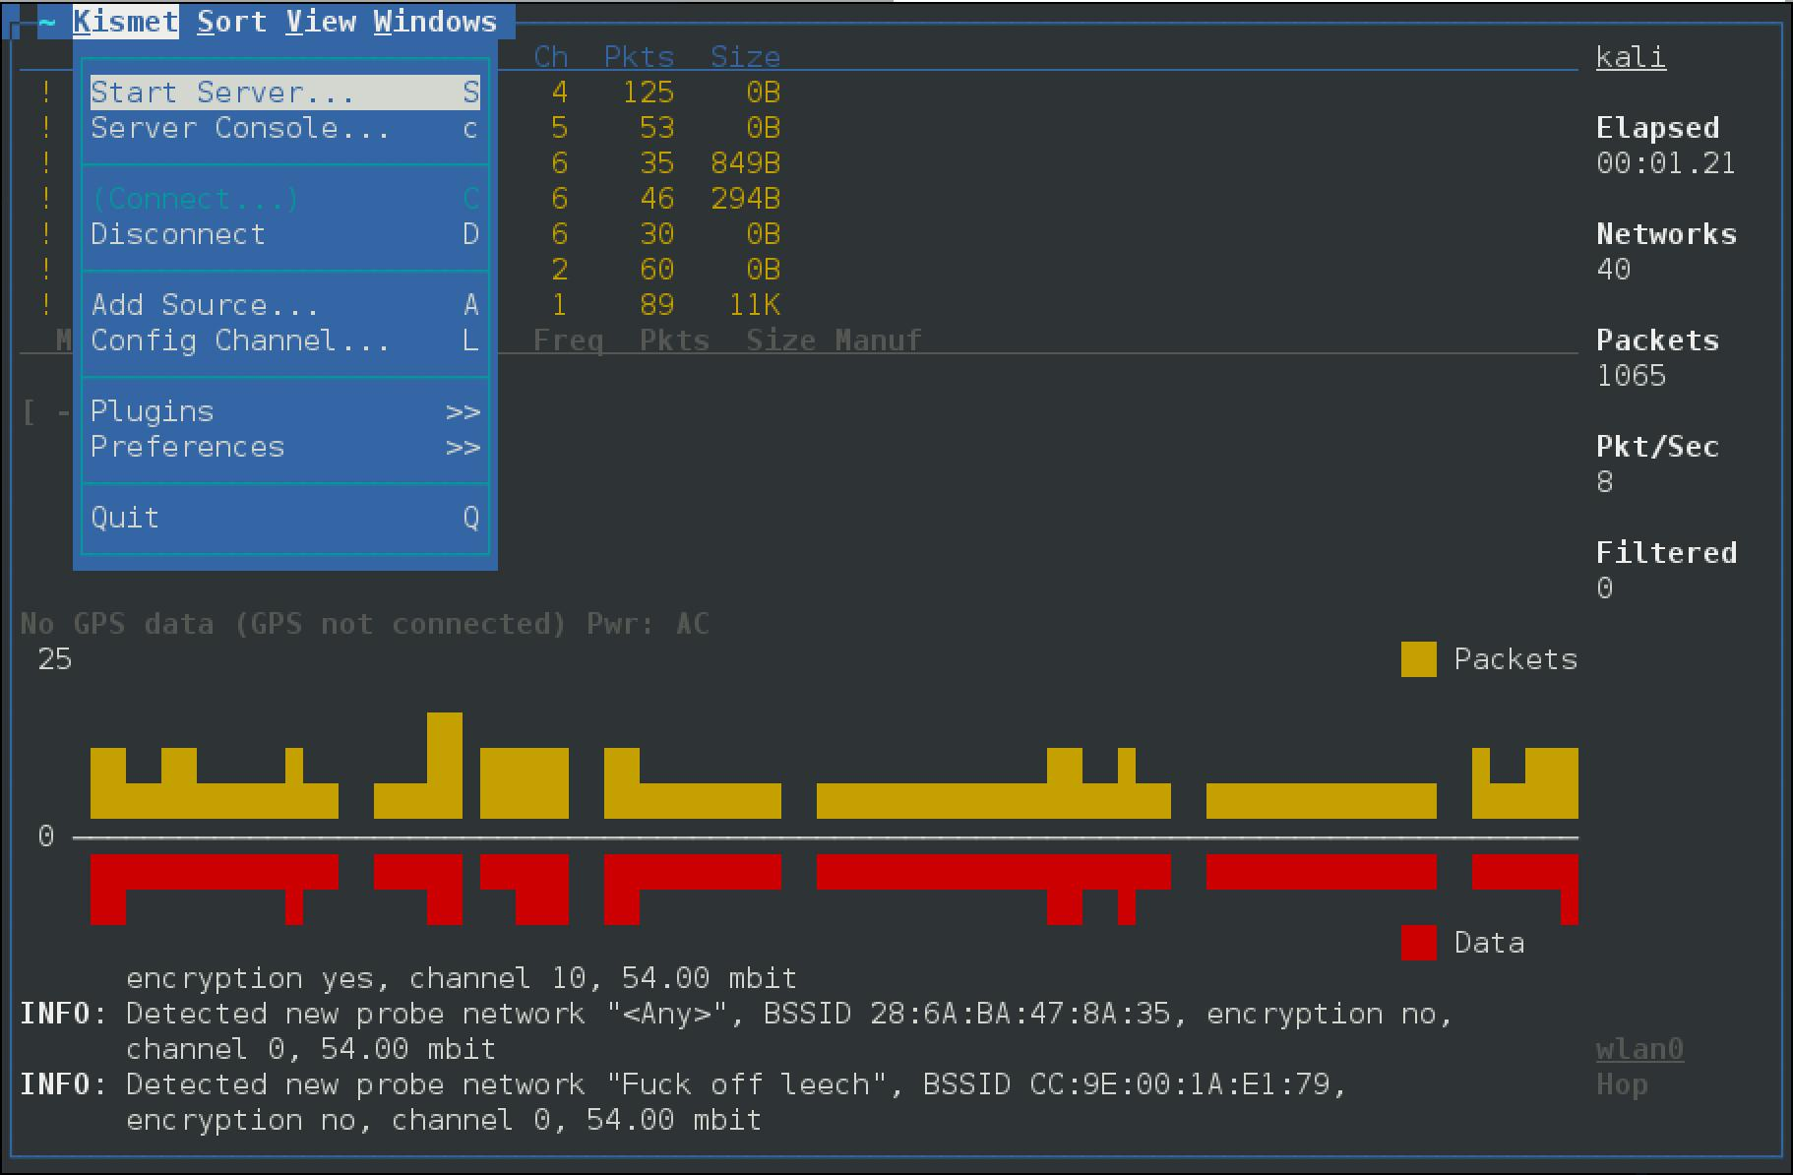
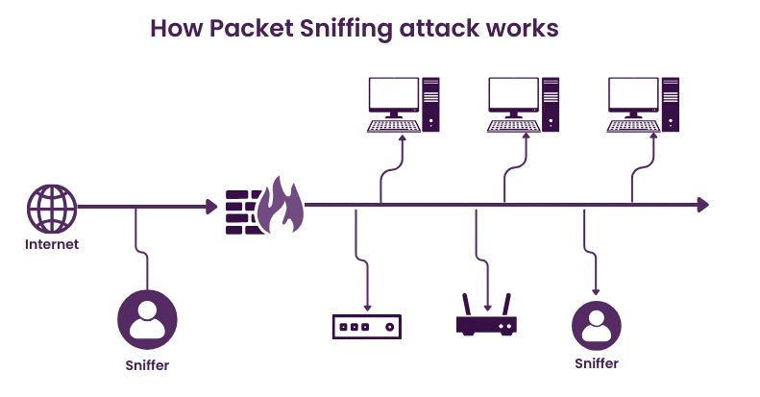

🔹 Name
Wireless Security Assessment

🔹 Tools
- Kismet
- Aircrack-ng

🔹 Setup
- Use USB WiFi adapter (monitor mode)
- Prefer Linux (Ubuntu)

🔹 What It Does
- Detect rogue APs
- Identify weak encryption
- Monitor clients

🔹 Output
- SSID list
- Encryption type
- Connected clients

🚀 PHASE 4: Traffic & Bandwidth Analysis

🟢 Step 4: Network Traffic Monitoring
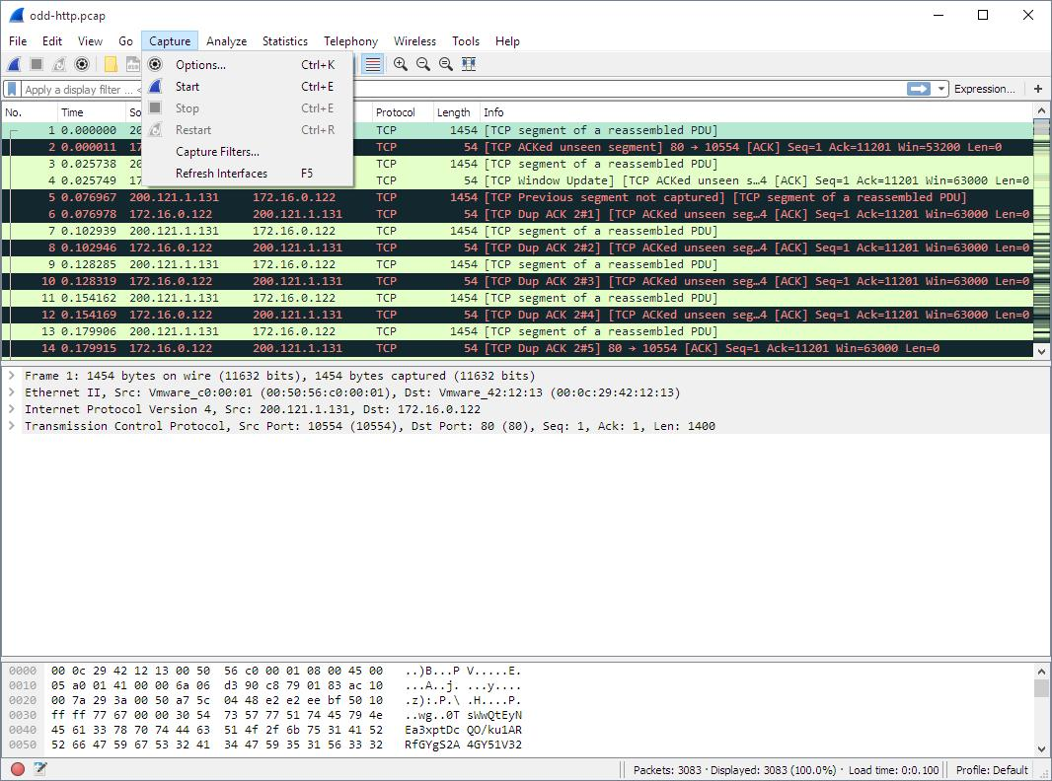
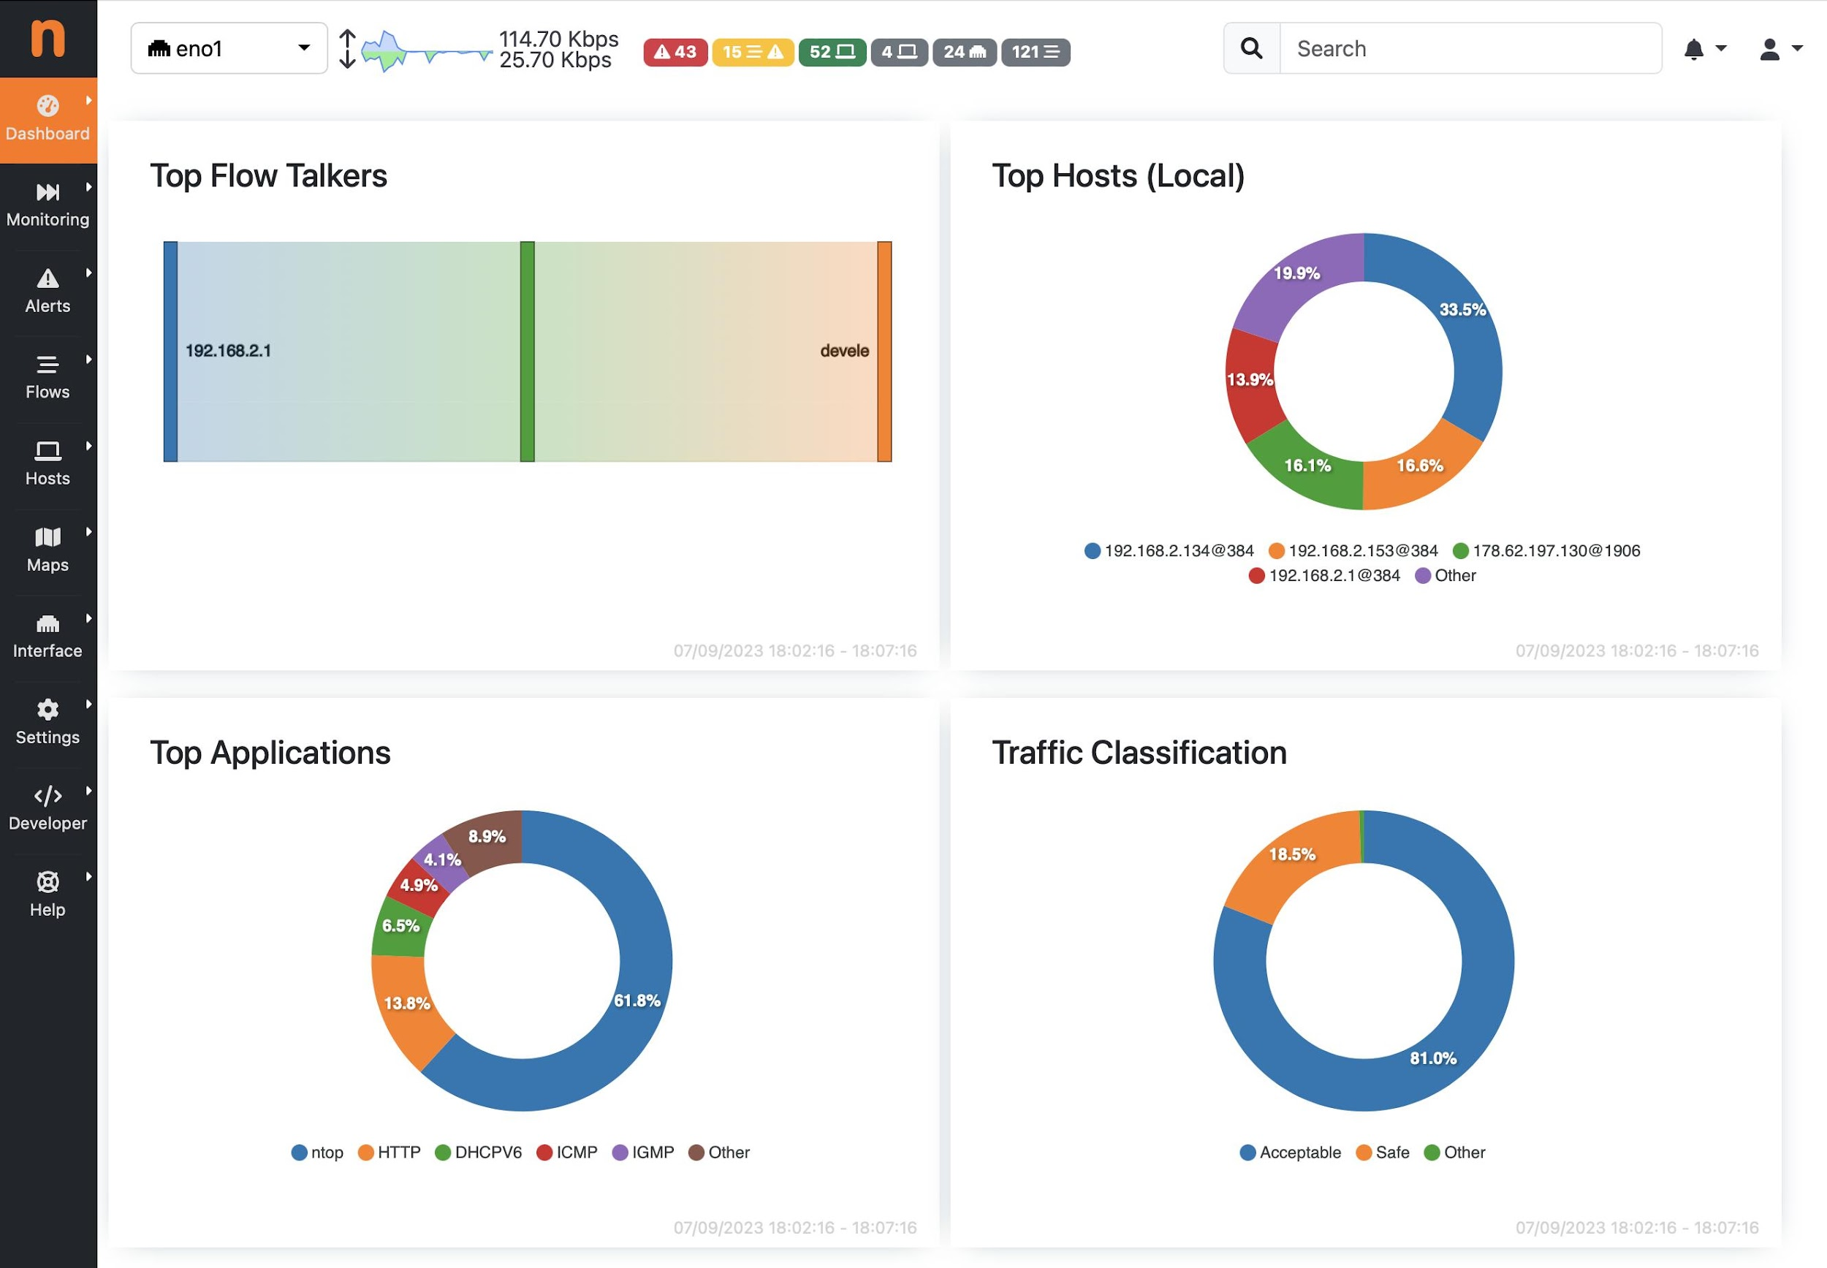
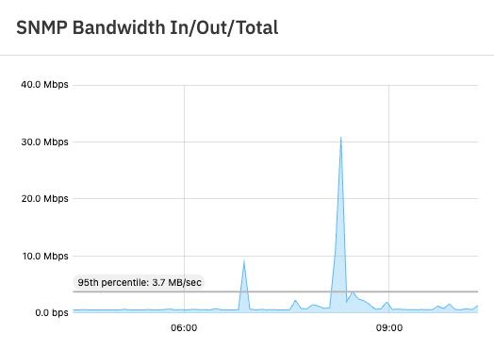
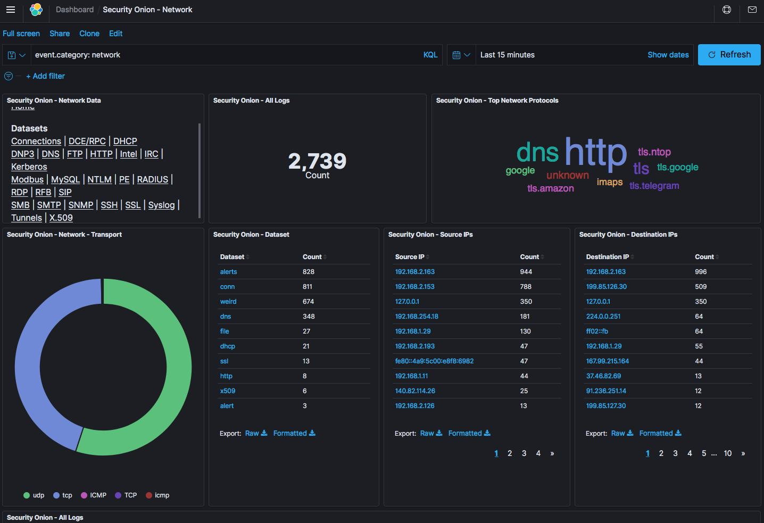
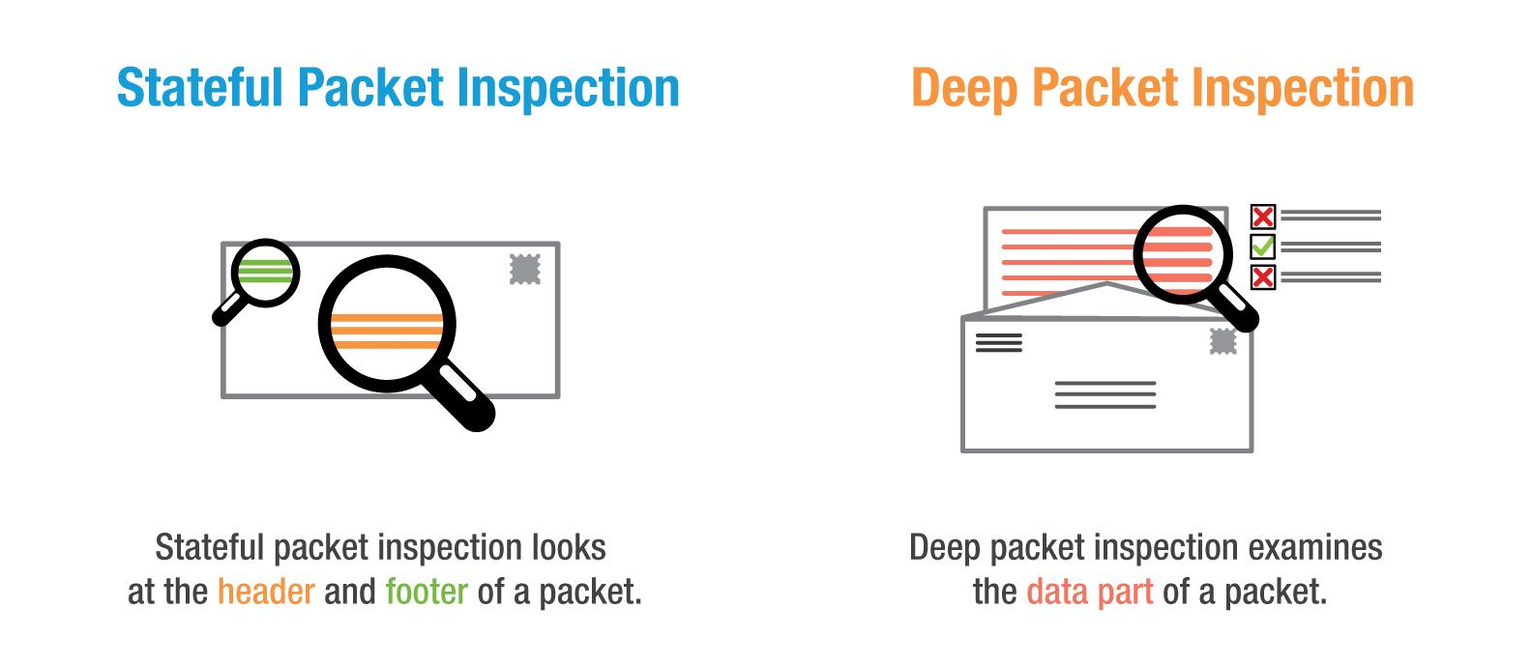
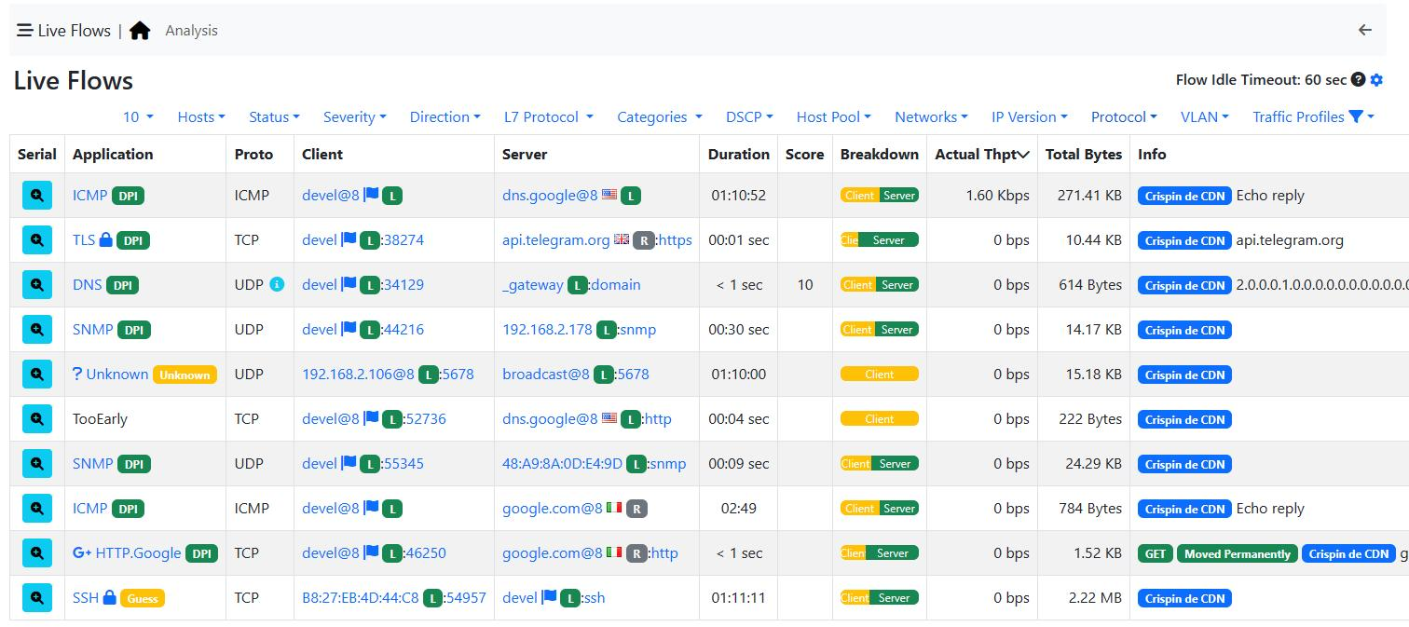

🔹 Name
Network Traffic & Bandwidth Analysis

🔹 Tools
- Wireshark
- ntopng

🔹 Setup
- Connect to SPAN port

🔹 What It Detects
- Data exfiltration
- Suspicious traffic
- Bandwidth hogs

🔹 Output
- Traffic logs
- Top talkers

🚀 PHASE 5: Internet & Browser Security

🟢 Step 5: Browsing Behavior Analysis

🔹 Tools
- PowerShell (browser configs)
- Wireshark

🔹 What to Extract
- Proxy settings
- Installed extensions
- Saved credentials (limited)

🔹 Outcome
✅ Unsafe browsing detection

🚀 PHASE 6: Email Security Analysis

🟢 Step 6: Email Header Analysis

🔹 Tools
- PowerShell
- Python (email parsing)

🔹 Approach
- Extract sample emails from:
  - Outlook PST/OST

🔹 Script Concept
# Outlook COM object (basic)

🔹 Analyze
- SPF / DKIM
- Phishing indicators

🔹 Outcome
✅ Email spoofing risk detection

🚀 PHASE 7: Vulnerability Assessment

🟢 Step 7: Vulnerability Scan
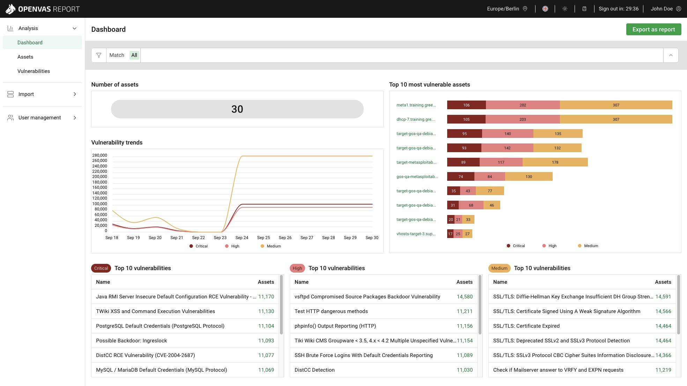
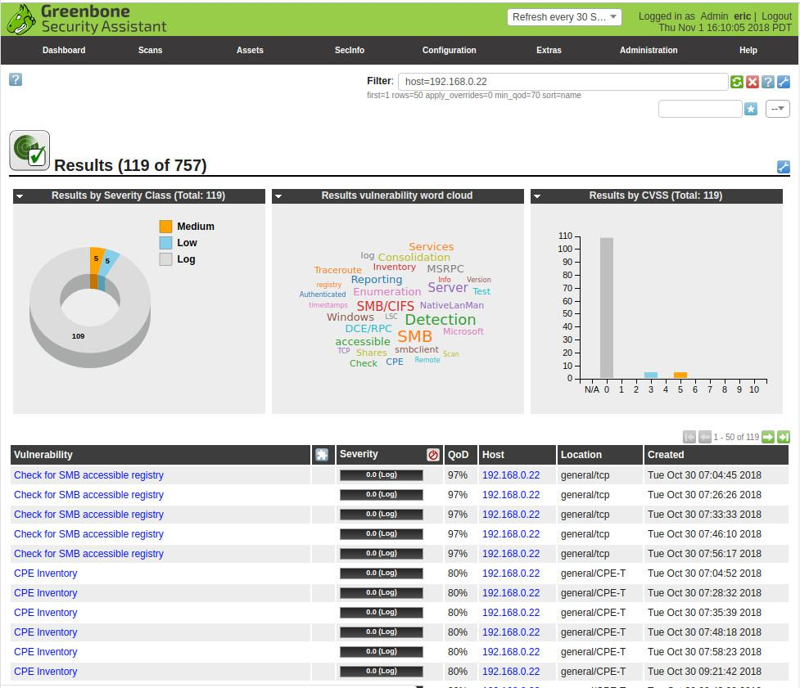
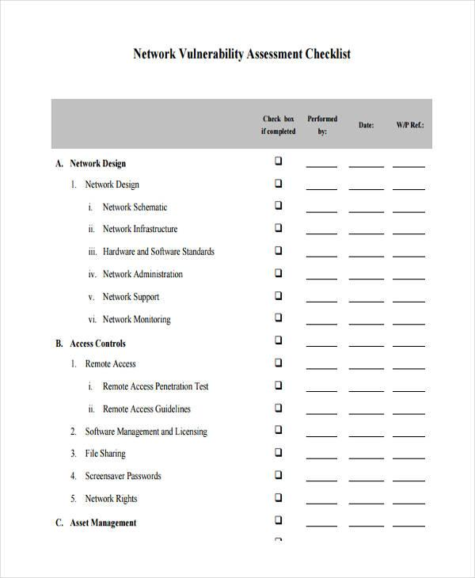
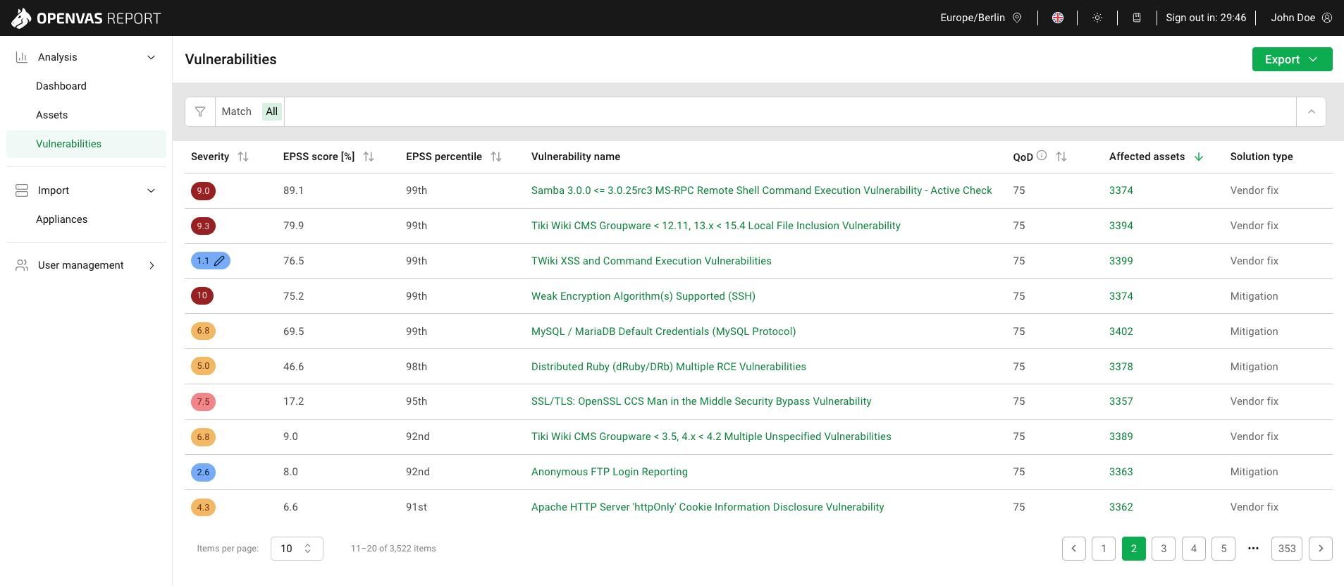
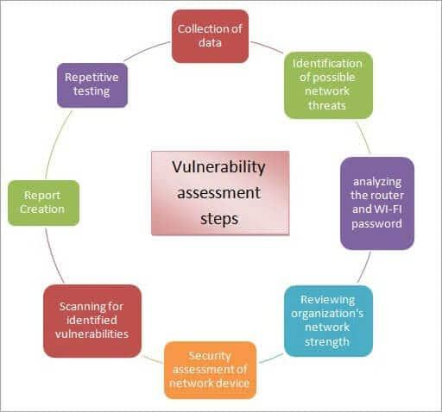
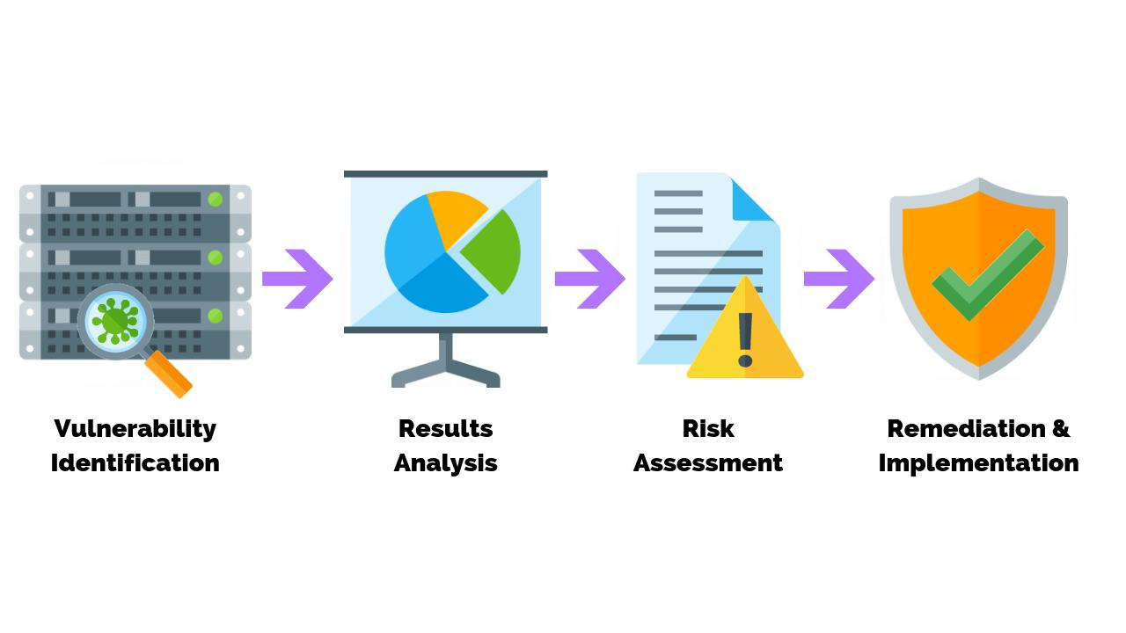

🔹 Tools
- OpenVAS

🔹 What It Does
- Detect CVEs
- Patch gaps
- Weak services

🔹 Output
- Vulnerability report

🧠 FINAL ARCHITECTURE SUMMARY

🔗 Flow
- Nmap → Discover devices
- PsExec → Execute PowerShell audit
- Kismet → Wireless scan
- Wireshark → Traffic capture
- Scripts → Email + browser analysis
- OpenVAS → Vulnerabilities

🔥 What Makes This Powerful (DXSO Advantage)
You are combining:
- Agentless + Agent-based hybrid
- Network + Endpoint + User-level visibility
- Affordable for MSMEs
👉 This is rare in this price segment

⚠️ Important Constraints (Reality Check)
- Pirated OS detection → heuristic only
- Email access → permission sensitive
- WiFi monitoring → needs Linux adapter
- Remote execution → firewall challenges

🚀 Next Step (Highly Recommended)
I can now help you build:
✅ A single orchestrator script (Python)
- Runs all steps
- Calls tools
- Collects outputs
- Generates final report
👉 Say: “Build DXSO orchestrator” and we’ll convert this into a working product.

